We, the undersigned residents of Seaford object to this proposed development, not only to the proposal in itself but to what it represents for the future of Seaford.
Neighbourhood Character
The Neighbour Character Statement (Seaford 5) describe this precinct as:
An area with a consistent low scale, horizontal emphasis of dwelling form and predominantly low, solid front fences creating a spaciousness in the streetscape. The area has something of a ‘garden suburb by the sea’ character, with the mixed dwelling styles set in established gardens, its grid pattern of streets, and early post war housing. This character is assisted by the open sky vistas that are found on the flat land near the sea.
With

Key Existing Characteristics
- Architecture is generally single-storey interwar - 70s styles, with a dominance of 50s styles
- Mixed brick, timber and fibro and mixed roofs
- Front setbacks are medium to large with 3-4 metre side setbacks
- Gardens are established with mixed vegetation
And

COMMUNITY VALUES
The following aspects of the area are valued by the community:
- Seaford Wetlands and Kananook Creek environs.
- Large trees and tree canopy
- Diversity of houses
- Buildings that are appropriately scaled and don’t overlook adjacent properties.
And

PREFERRED NEIGHBOURHOOD CHARACTER STATEMENT

The spaciousness of the streetscape is to be maintained, and the coastal garden settings and relationship with the creek and wetlands environs are to be strengthened by:
- Providing space for large tree planting
- Encouraging planting of indigenous trees and shrubs
- Ensuring new buildings respect the low scale of the existing dwellings
- Ensuring buildings respect neighbouring front setbacks
- Ensuring buildings are setback from at least one side boundary

And
THINGS TO AVOID:
- Removal of high canopy trees Boundary to boundary development.
- Buildings located on the creek or wetlands boundary.
- Large, bulky buildings with unarticulated walls facing the creek or wetlands

All of the above accords well with what Seaford residents want. People choose the location in which they live very much in accordance to what appeals to them in that location whether it be proximity to local services or living with like-minded people, or, as in the case of Seaford, its natural amenities – its openness; its single-dwelling blocks with gardens and canopy trees; and its environmental gems – beach and beach reserve, creek and creek reserve and its Ramsar protected wetlands.
Unfortunately, there is an inherent problem in the idea of neighbourhood character if it is not strongly protected. Seaford has traditionally been a suburb of a single dwelling, mainly single-storey buildings set in their own gardens. Every time there is a development over and beyond this, there is an incremental change in the neighbourhood character, which subsequent developers try to use to further their applications (as has this proponent - pages 36, 40) – the cycle continues until there is a tipping point and the neighbourhood character completely changes. A development like this contributes to this process and should be disallowed. There seems to be no point otherwise in having Neighbour Character Statements.
This development proposal occupies far more land than the existing building does with the loss of most of the back yard and two large well -established gum trees.
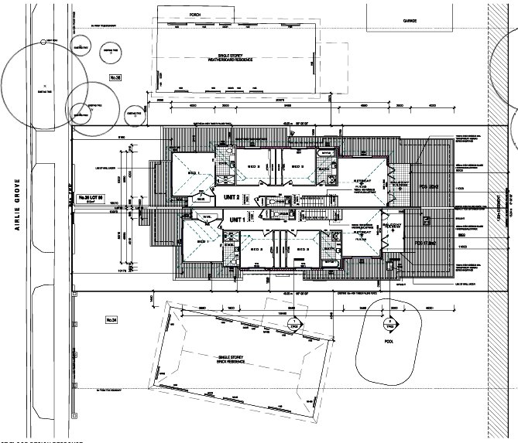
Darker area represents ground floor
Wetlands
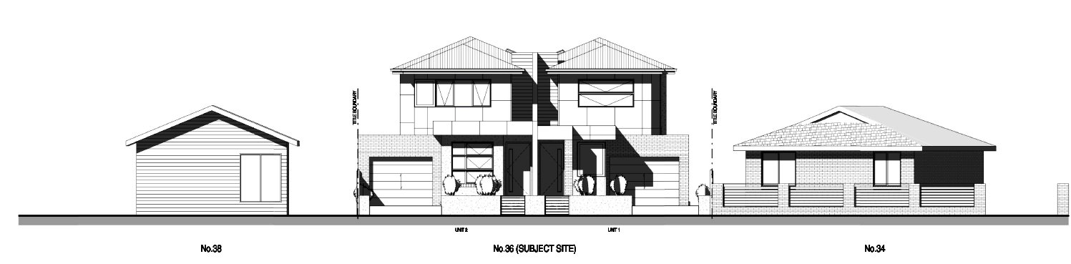
How does this visually fit in with existing neighbourhood character?
There are 5.4 meters of rear garden, and the proposed building is very close to the north and south boundary fences (actually on part of the northern boundary). This does not accord with the Preferred Neighbour Character Statement
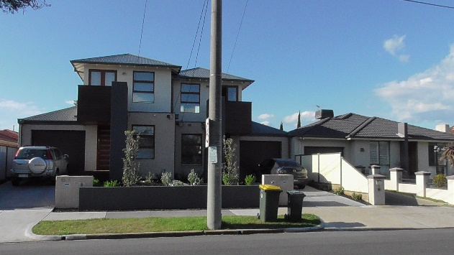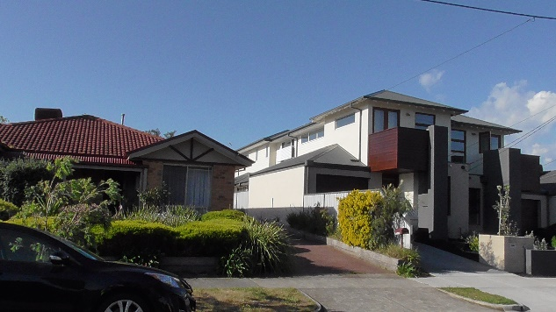
A similar development in Seaford – dwarfing the houses next to it.

Rights of Neighbours
Who would want this on their side boundary fence?
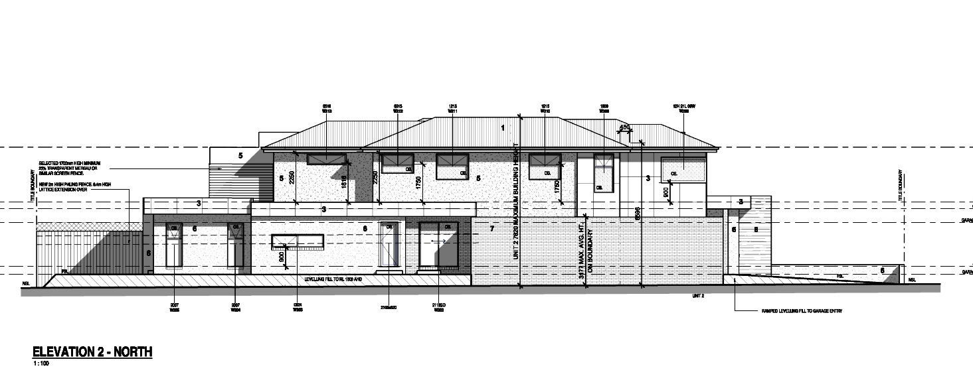
In this sort of development proposal there never seems to be any regard for neighbours’ rights. It seems that all the rights belong to proponents who are developing/building and none for next-door residents. Why? There is no doubt that this kind of development compromises a next-door resident’s amenity (garden and home) and causes a probable devaluation of their properties. Why hasn’t a neighbour’s right to continue to enjoy the amenity of their residence and garden equal validity?

Loss of Trees
This development proposal requires the removal of two well established gum trees – one (Mahogany Gum) with a height of 26 meters. This loss represents yet another nail in the coffin of tree loss in Seaford and should be strongly resisted.

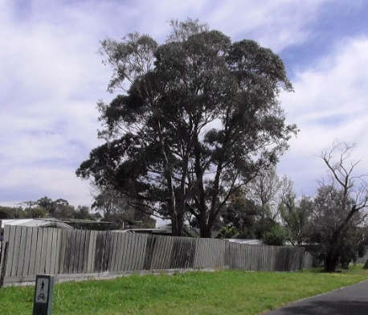
The two trees in the rear yard of 36 Airlie Grove, Seaford

The Arboricultural Report

Conclusion and Recommendation

There are only two large eucalyptus trees in the backyard of the subject site. Being large and native, they are considered of Medium retention value considering their less than perfect conditions.
Tree-1suffers from severe lerp infestation, whereas Tree-2 overshadowed by Tl only has half a canopy which becomes P-shaped and unbalanced. Also it has a track record of past limb drop incidents which will be a safety problem in a residential allotment. Because both trees are inside the proposed building envelopes, their retention is not feasible in this design (and their removal is shown in dotted lines in the design plan) and their removal is required if the design is endorsed.
Their removal loss can be compensated by appropriate net gain compensation new replantings in a proper landscape plan to be submitted with this application.

We argue that:
- Lerp infestation cycles come and go (at the moment many of the trees in this vicinity are suffering the same infestation). “… occasionally and without any obvious regularity, they may suddenly increase enormously in numbers and sometime later, just as suddenly disappear”. (Lerps Insects Number 6 Revised October 1992 By Charlma Phillips, Principal Forest Health Scientist)
It is a temporary condition - this tree must have weathered many such infestations during its life.
- New re-plantings cannot compensate for the loss of the Mahogany Gum. Firstly, it would take many, many years to reach the same level of maturity and secondly people with balconies are often reluctant to have their views obscured by vegetation.
With reference to scale, the size of the front and back gardens suggest that smaller trees and shrubs are more likely to be considered.

The loss of canopy tress in Seaford is happening at a great rate – over the past two or three weeks, in nearby Park Street alone, six large canopy trees have been cut down. Why allow a non-resident developer to remove our precious trees so that he can increase his profits. Seaford residents get nothing out of the deal but another loss.

Wetlands

This proposed development is right on the very edge of the Seaford Wetlands.
This contravenes The Neighbour Character Statement (Seaford 5)
Things to Avoid:
- Buildings located on the creek or wetlands boundary.

Our urban wetlands are precious and are already under pressure from urban development on its boundaries.

The proposed building is within 5.5 meters of the property’s rear fence, is double-dwelling double-storey with rear balconies, visually totally out of character with the nearby houses from the wetland point of view; it is intrusive and defeats the purpose of buffer zones (very narrow at this point) which are designed to reduce the impact of human disturbance on the wetlands.

Just a Short Note on Population Increase

Our population is increasing at a phenomenal rate, courtesy of Government policy.

Given our declining natural resources, economic slowdown, increasing demands for services, traffic congestion, pressures on our urban and natural environments, and climate change it makes no sense to support such growth.
Population increase cannot continue ad infinitum. At some point in time a line needs to be drawn. That the time is now. Our population needs to be stabilised to a manageable level as a precedent to achieving zero population growth.
Despite the fact that the Victorian Government is developing a new suburb in the west and is looking to develop some regional towns, it is mainly looking to Melbourne municipalities for an easy solution to its problem of absorbing these numbers without extending the urban growth boundaries.
The Victorian Government needs to be made aware of the crucial importance of slowing population growth, and municipalities need to deny accommodation in this matter. If the Government is forced to come up with other solutions, its enthusiasm for massive population increase may wane.
Councils need to play their part in this. Boroondara Council is prepared to take this on (Herald Sun, 28th November2016). Why not Frankston Council?

We residents of Seaford urge the Council to reject this proposed development.

